“He fed them with the finest wheat and satisfied them with honey from the rock”.
(Psalm 80:17)

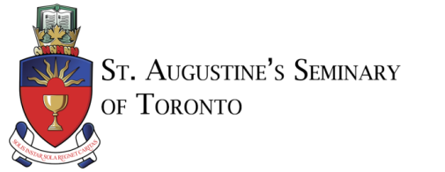
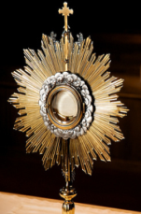
EUCHARISTIC ADORATION
The Blessed Sacrament will be
exposed Monday to Saturday from
11:00 am – 1:00 pm and on Sunday
from 9:00 am – 1:00 pm
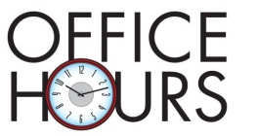
Monday, Thursday & Sunday:
10:00 am – 2:00 pm
& by appointment only, please call the Office directly at 416-923-8471.
Tuesday, Wednesday, Friday & Saturday:
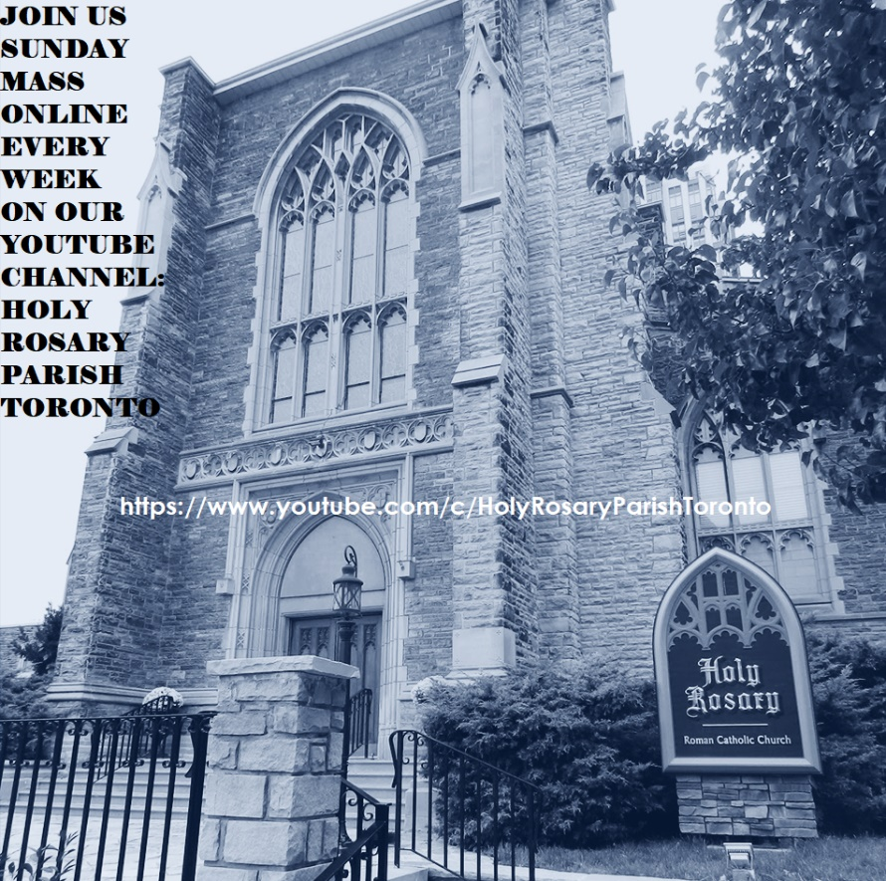
The Parish Office is CLOSED
Please join us for Sunday Mass Online:
A recording of the Mass on our YouTube Channel: https://www.youtube.com/c/HolyRosaryParishToronto/Each week we will continue to upload the recorded Masses on Saturday evenings after 5pm. We all look forward to the opportunity to gather again as a parish community in our church. Until that time, be assured of our prayers for all of your intentions. Sincerest thanks to you for your prayers and continued support.
COME HOLY SPIRIT NOVENA VIDEOS
https://www.staugustines.on.ca/about/events/novena_video
SONGS FROM THE SEMINARY
https://www.staugustines.on.ca/about/events/songs_from_the_seminary
The Holy Rosary Catholic Women’s League (CWL) is calling out to young ladies in Grades 11 & 12, attending a Catholic high school and will be applying for a post-secondary education to the University of Toronto. The CWL of Canada offers a
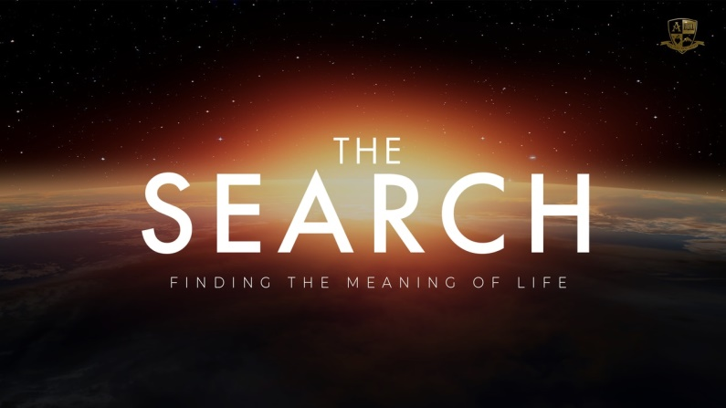
St. Michael's College Scholarship opportunity to these ladies. For more details about scholarship eligibility, please contact Amy Domingo at amy_domingo@hotmail.com or if have any questions about the Holy Rosary CWL please contact Mary Jane at maryjane.cwl@gmail.com.
Pulling together the best in Catholic movies, What is this journey in between the event we call “birth” and the one we call “death”? Is the journey taking you somewhere, or are you leading yourself to some kind of destination – a destination that could extend beyond your last breath? What do you want from your life during the in between? The questions are there. And, the answers are too. To register, for
FREE, go to: www.formed.org and enter the
Parish Code: FVT2H9.
MASS INTENTIONS
Monday, June 14, 2021
12:10 pm. Frank McGraw (+)
Requested By: Mary & David McGraw
Tuesday, June 15, 2021
12:10 pm. Theresa Wolak (+)
Requested By: Lan Truong

Wednesday, June 16, 2021
12:10 pm. Isabel Muniz (+)
Requested By: The Landolfi family

Thursday, June 17, 2021
12:10 pm. Mr. George Morgan (+), Dr. Paul R.
Morgan (+), and Dr. George (+) & Patricia Morgan (+)
Requested By: Their Sisters

Friday, June 18, 2021
12:10 pm. The Honorable, George W. Vari (+)
Requested By: His Wife, Helen Vari

Multiple Intentions:
Victoria (Vicky) Gerra (+), Joan Madeleine Foy (+), Nelly (+) & Ouan Vasquez (+), For Healing: Raul Sanchez & For Special Intentions: Miguel Sanchez

Saturday, June 19, 2021
5:00 pm. Giosina Medaglia (+)
Requested By: Gayle Comeau

Sunday, June 20, 2021
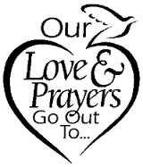
Twelfth Sunday in Ordinary Time
8:00 am. Holy Rosary Parishioners
10:00 am. Lou Boyd (+)
Requested By: The Fleming Family
12:00 pm. Nilda Pentinio Barberan (+)
Requested By: Helen Fabro

Monday, June 21, 2021
12:10 pm. Ivan Jelen (+)
Requested By: Paulina Jelen & Family

Tuesday, June 22, 2021
Saint Thomas More
12:10 pm. Alfonz Pavli (+)
Requested By: Frank, Theresa, Alexander, Philip &
Simone Protommani

Wednesday, June 23, 2021
12:10 pm. Rose Marie Lawless (Special Intentions)
Requested By: Cathy Feghali & Family

Thursday, June 24, 2021
The Nativity of Saint John the Baptist
12:10 pm. Souad Feghali (Special Intentions)
Requested By: The Feghali Family

Friday, June 25, 2021
The Most Sacred Heart of Jesus
12:10 pm. Violet Czernkovich (+)
Requested By: Nick & Kathy Czernkovich

Multiple Intentions:
Joe Malfara (+), Victoria (Vicky) Gerra (+), Joan Madeleine Foy (+), & For Special Intentions: Daniel, Meghan, Beri & Oscar

Saturday, June 26, 2021
5:00 pm. Angela Melo (+) & Parents
Requested By: Maria Sousa

Sunday, June 27, 2021
Thirteenth Sunday in Ordinary Time
8:00 am. Holy Rosary Parishioners
10:00 am. Don Bruce (+)
Requested By: Lucy Bruce
12:00 pm. Juliana Ramos-Ashfur (+)
Requested By: Helen Fabro

Please remember in your prayers
those who are sick, especially:
George Marcello, Dominico Huynh Van Minh, Dominic Truong Huu Luong, Mr. Vincent Tran Ngoc Hung, Mimi Allemand, Moira Duff, Maureen Morenz, Allan Brown, Ofelia Dollete, Marlene del Rosario, Margaret Kolada, Victoria Gerra, Michael Naraine, Maria Carlos, Kevin Caradona, John de Francesco, Maryleigh Picchetti, Guiseppina Zampini, Clare De Mello, Messias Sousa, Agetina Leka, & for those who have tested positive for COVD-19.
Please remember in your prayers
all who have recently died, especially,
Victoria (Vicky) Gerra (+), Joan Madeleine Foy (+), Joe Malfara (+), Delfino Rossetti (+), Yvette Hamel (+), Mary Ellin Montague LaMuraglia (+), Correas Lazaro (+), Maria Concepcion Nonan (+), & for those who have died due to COVID-19.

