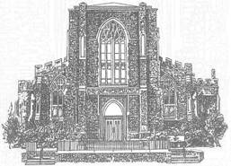
Holy Rosary Church
354 St. Clair Ave. West
Toronto, ON M5P 1N4
416-923-8471

Baptismal Information

Name of Child _________________________________________________
(as the child’s name should appear on the Baptism Certificate, last name underlined)

Male ☐ Female ☐

Date of Birth _______________ Place of Birth _______________________

Name of Father ____________________ Religion__________________

Name of Mother _____________________ Religion __________________

Maiden Name __________________________________

Address ___________________________________________________________

Postal Code ___________________ Phone Number __________________

Name of Church where the parents married _____________________________

Sponsor/Godparents:

- _______________________ Religion _______________________

- _______________________ Religion _______________________

Office Use Only

Do the parents regularly attend Holy Rosary Parish? Yes ______ No _____

Date of Baptismal Course _______________________________

Date of Baptism ______________________________

Baptized by ____________________________

Interviewed by ________________________ Date ___________________

Other Annotations: ____________________________________________________

_____________________________________________________________________

